Automatic classification of protein structure by using Gauss integrals (2002, 219 citations)

Gauss integrals for protein topographical measurements

“scaled gauss metric” – SGM

CATH 2.4 database is a database for protein families

Using knot theory and the triangle inequality to create an SGM of the protein

<https://www.pnas.org/content/pnas/100/1/119.full.pdf>

Optimal breast cancer classification using Gauss–Newton representation based algorithm (2017, 25 citations)

GNRBA - Gauss-Newton representation based algorithm

L1 norm used to calculate distance between malignant and benign tumors

y = x1β1 + x2β2 + ···+ xNβN

SSE error with multiple tests for training data

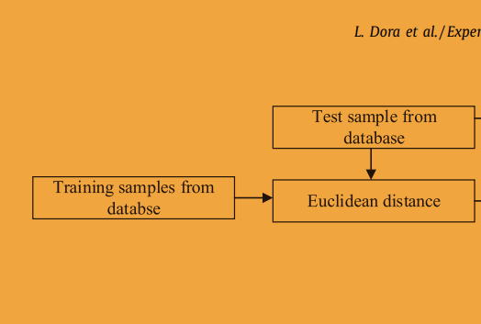

<https://www.sciencedirect.com/science/article/pii/S0957417417303597>

Lloyd’s algorithm:

Finding the centroids of cells

